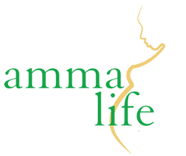

**Social Media Volunteer**

**Role**

Ammalife is a specialist, research driven organisation that is committed to tackling obstacles to good maternal healthcare in some of the world's poorest countries. Over the past decade, Ammalife has contributed to innovative and ground-breaking research in the field of maternal health. Ammalife’s major support base has traditionally been individuals from the medical and maternal health community. We are now seeking to widen our support base and to promote issues of maternal health to the general public.

As a social media volunteer, you will help us to achieve our aim of reaching a wider audience. You will help us to create and schedule visually appealing posts for our existing Facebook and Twitter accounts using online graphic design tools, as well as to help us set up accounts on other social media platforms and to upload new content. You will also provide us with a short monthly report on our social media activity, conducting basic analytics on our reach and engagement.

**Skills and Experience**

You will have excellent online communications skills and be proficient in a range of different social media platforms. You will be creative, with a good eye for design. You will also have good attention to detail and good command of written English. You will be able to commit to at least 3 hours per week for at least three months.

**What will I gain from this role?**

Whilst this position is voluntary, you will have the opportunity to gain experience in the charity sector, and to learn transferable social media and marketing skills. You will also be contributing towards our vital work helping to improve healthcare outcomes of mothers in some of the poorest areas of the world.

**Application Process**:

Please send a CV and a brief motivational statement to [info@ammalife.org](mailto:info@ammalife.org) by **5pm** on **Thursday 28th February.** Please note this is an unpaid voluntary role.